**Revision – Molecules and Moles**

|  |  |
| --- | --- |
| **Equations $$n=\frac{m}{M_{r}}$$** | $$N=n ×N_{A}$$ $$N_{A}=6.022×{10}^{23}$$ |

1. Fill in the gaps and place the examples in the appropriate boxes:

***Word bank:***Compounds, Heterogeneous, Homogenous, Pure Substances, Elements, Mixtures.

***Examples*:** Salt Water (NaCl, H2O), Copper, Brass (Alloy of Cu + Zn), Salt (NaCl), Water (H2O), Carbon, Pizza, Water, Aluminium, Concrete

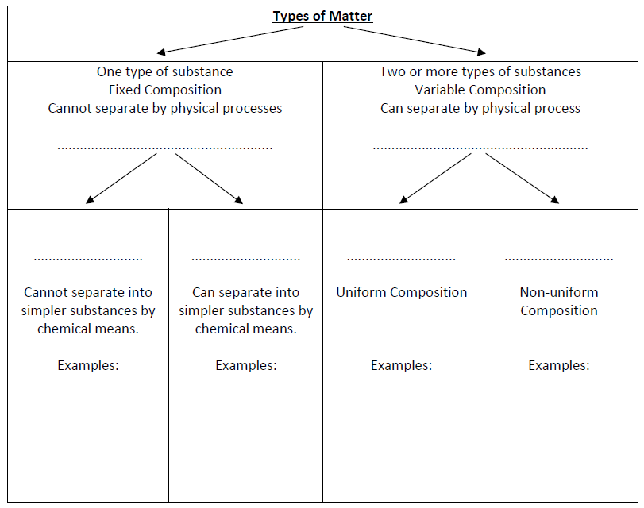

1. How many molecules are in 500 g of sucrose (chemical formula C12H22O11)? $$\text{Number} \text{of} \text{molecules}≈8.794×{10}^{23}$$
2. What is the mass of 0.63 mol of glucose, C6H12O6? $$\text{Mass}≈113.497 g$$
3. If a chemist wanted 0.05 moles of sodium hydroxide, how much would they need to weigh out? $$\text{Mass}=1.99984 g$$
4. The Statue of Liberty contains 27 metric tonnes of copper. How many atoms does this represent? (Hint: Remember to convert to grams!) $$\text{Number} \text{of} \text{atoms}≈2.558⋅{10}^{29}$$
5. What percentage of nitrogen is there by mass in 1 mol of ammonia?

82.

1. The oxygen transporting subunits of haemoglobin are known as heme molecules. What is the percentage of iron by mass in a heme molecule (C49H56FeN4O6)?
2. What is the mass in g of 1.5 x 1022 molecules of sodium chloride?
3. Consider a 1.00 carat diamond (pure C) that has a mass of 200 g. How many carbon atoms are present in this diamond?
4. a) How many moles of ethanol are present in 100.0 g of ethanol, C2H6O?

b) How many moles of each element (C, H, O) are present in 100 g of ethanol?

c) How many grams of each element (C, H, O) are present in 100 g of ethanol?

1. How many carbon atoms are found in 0.500 g of glycine, H2NCH2COOH?
2. Indicate whether any of the following statements is true or false, and explain your reasoning.

a) One mole of NH3 weighs more than one mole of H2O.

b) There are more carbon atoms in 48 grams of CO2 than there are in 12 grams of diamonds (C).

c) There are equal numbers of nitrogen atoms in one mole of NH3 and one mole of N2.

d) The number of copper atoms in 100 g of copper (s) is the same as the number of copper atoms in 100 g of copper (II) oxide.

e) The number of Ni atoms in 100 moles of Ni (s) is the same as the number of Ni atoms in 100 moles of nickel (II) chloride, NiCl2.

f) There are more hydrogen atoms in 2 moles of NH3 than in 2 moles of CH4.